PRELUDE

Welcome to Philadelphia UMC
April 6, 2025
WELCOME AND ANNOUNCEMENTS

*CALL TO WORSHIP
We come to worship, remembering God’s goodness that has carried us and sustained us to this present moment.
We remember the days when God covered us in love and filled us with joy.
We come to worship, weary from stress, heavy with grief, and wondering when relief will come.
We long for the days God covered us in love and filled us with joy.
We come to worship to remember and remind one another that God’s love has never left us, and God’s joy cannot be extinguished.
God, restore us that we know your love and your joy once again.
We come to worship to remember and become the Body of Christ, a community called to restore the world around us.
God, empower us to be your reconciling people who fill the world with love, laughter, and abundant life. Amen.
Written by Dr. Lisa Hancock, Discipleship Ministries, September 2024.

*HYMN “Come Thou Fount of Every Blessing” UMH #400

*THE APOSTLES ’ CREED UMH #881
I believe in God the Father Almighty,
maker of Heaven and Earth;
And in Jesus Christ His only Son our Lord:
who was conceived by the Holy Spirit,
born of the Virgin Mary, suffered under Pontius Pilate,
was crucified, dead and buried;
the third day he rose from the dead; he ascended into heaven,
and sitteth at the right hand of God the Father Almighty;
from thence He shall come to judge the quick and the dead.
I believe in the Holy Spirit, the holy catholic church,
the communion of saints, the forgiveness of sins, the resurrection of the body, and the life everlasting. Amen.

*GLORIA PATRI “Glory be to the Father, and to the Son and to the Holy Ghost; as it was in the beginning, is now, and ever shall be, world without end. Amen.”

CHILDREN’S MOMENT

SCRIPTURE READING Psalm 51:1-12 Wes Shortridge

PRAYERS, PRAISE, AND THE LORD’S PRAYER
Our Father who art in heaven, hallowed be thy name Thy kingdom come, thy will be done, on earth as it is in heaven. Give us this day our daily bread. And forgive us our trespasses, as we forgive those who trespass against us. And lead us not into temptation, but deliver us from evil. For thine is the kingdom, and the power, and the glory, forever and ever. Amen.

TITHES AND OFFERINGS
*THE DOXOLOGY UMH #95

CHOIR ANTHEM

SCRIPTURE READING 2 Corinthians 5:17-21a
SERMON Radical Renovation: Reconciliation Rev. Melissa Shortridge

HOLY COMMUNION UMH# 12

*HYMN “Jesus Calls Us” UMH #398

*THE BENEDICTION
*THE POSTLUDE
*Those who are able, please stand.

Weekly Prayer List
Family of Gerri Goforth (Nancy Sandifer’s mother), Kayla Brooke Cook, Darrell Barrentine, Bill McKown, Cathy Miskelly, Cis Helms, Brenda Sandifer, Gabe (Bob & Dixie’s grandson), Carole Ramsey, family of Judith Turrill, Amanda Branch, Jimmy Knight, Lucy Vecchio, Linwood Littlejohn, Mason Knight, Fran Dodds & family, our country, and our church family.

ANNOUNCEMENTS

Welcome to Worship at Philadelphia United Methodist Church!
We are delighted you have chosen to worship with us this morning!

Opportunities This Week

TODAY Lenten Bible Study 10:30am
Choir Practice 6:00pm

***************************************************************************************
Upcoming Events

Mar 9th-Apr 13th – (Sundays) 10:30am; We will begin a Lenten Bible study after church beginning March 9

Apr 14th – 18th – 11:30am-12:30pm, Holy Week Services sponsored by the York County Ministerial Association will be at First Presbyterian Church, 10 W Liberty St., York. Lunch will be provided. Philadelphia UMC will be responsible for desserts on Friday. Speakers: Monday -Bishop Alfred, Tuesday-Rev Ed Kelly, Wed- Rev Ed Spaulding, Thurs.-Rev Dave Hall, Friday-Rev Wanda Altman-Shirah

******************************************************************************************************************************************
Alcoholics Anonymous (AA) meets in the Fellowship Hall at Philadelphia UMC on Tuesdays and Fridays each week at 7:00pm.

**********************************************************
GIVING – Philadelphia UMC provides Online Giving – a convenient and safe way to make a one-time or recurring tithes and offerings. Visit our website, www.philadelphiayork.org, and click our Online Giving link.

**********************************************************
April 6th April 13th
Liturgist Wes Shortridge Bob Watson
Ushers Bob Watson & Wes Shortridge Miller & Wes Dover
Greeter Randy & Carol Sandifer Bob & Dixie Branch

Communion April May
Assistant Bob Branch Paul Shortridge

**Please send any announcements for the bulletin and/or calendar to Pastor Melissa, philadelphiaumcyork@gmail.com or (304)667-3444 by Wednesday of each week.

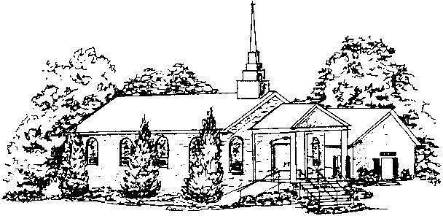

Philadelphia
United Methodist Church

2260 Chester Hwy
York, SC 29745
www.philadelphiayork.org philadelphiaumcyork@gmail.com

Sunday Service 9:30 am

Rev. Melissa Shortridge
Cell: 304-667-3444
melissadshortridge@gmail.com

Our Mission:
Knowing, Loving, Serving God
and Neighbor

